Kindergarten Year at a Glance 2012-2013

First Quarter Second Quarter Third Quarter Fourth Quarter

MATH Unit 1
3 Weeks
Kindergarten, Get Ready! Transition unit appropriate for teaching routines and procedures along
with foundational
math skills
- Numbers
- Shapes
MATH Unit 2
6 Weeks
Magical Math
Stories
Essential Questions:
 What is addition?
What is subtraction?
 How can I represent my thinking when solving addition and subtraction problems?
MATH Unit 3
9 Weeks
We’re Going on a Shape Hunt
Essential Questions:
 What shapes do we see in the world around us?
Which shapes are flat and which shapes are solid?
How can I use shapes to make new shapes?
What defines a shape?
MATH Unit 4
9 Weeks
Measuring Our World
Essential Questions:
What can I measure?

How can I measure the things in my world?
- How can I compare measures to show how things are alike or different?
Another compare link
MATH Unit 5
9 Weeks
Clever Comparisons
Essential Questions:

How can I compare sets of objects? How can I compare written numerals?

First Quarter Second Quarter Third Quarter Fourth Quarter

ELA Unit 1
6 Weeks
A Colorful Time with Rhythm and Rhyme Essential Question:
How does rhyme affect
the way that we hear and read poetry?

Science/S.S
5 senses (smell) /colors

Citizenships/ rights and responsibilities
ELA Unit 2
6 Weeks
Tell a Story, 1-2-3
Essential Question:
How are the beginning,
the middle, and the end of a story different from each other?

Science/S.S
Earth, moon, sun, and
stars

Magnets

Change over Time/Seasons
ELA Unit 3
6 Weeks
Exploring with Friends In the Neighborhood Essential Question:
How is reading like
exploring?

Science/S.S
Health

Wants/Needs

Community Helpers
MLK and P
ELA Unit 4
6 Weeks
America: Symbols and
Celebrations Essential Question: Why are symbols important?

Science/S.S
Types of Weather

Temperature

Democracy (citizenship, voting, government)
ELA Unit 5
6 Weeks
The Great Big World
Essential Question:
Why is it important for
writers to describe settings carefully?

Science/S.S
Physical Environment
Maps/globes Money Goods/services
ELA Unit 6
6 Weeks
Wonders of Nature: Plants, Bugs, and Frogs
Essential Question:
How does nature inspire
us as readers, writers, and artists?
Science/S.S
Living/non-living

Life Cycles

Columbus
Thanksgiving
Arkansas History
res. Day
Natural resources

Rogers Public Schools

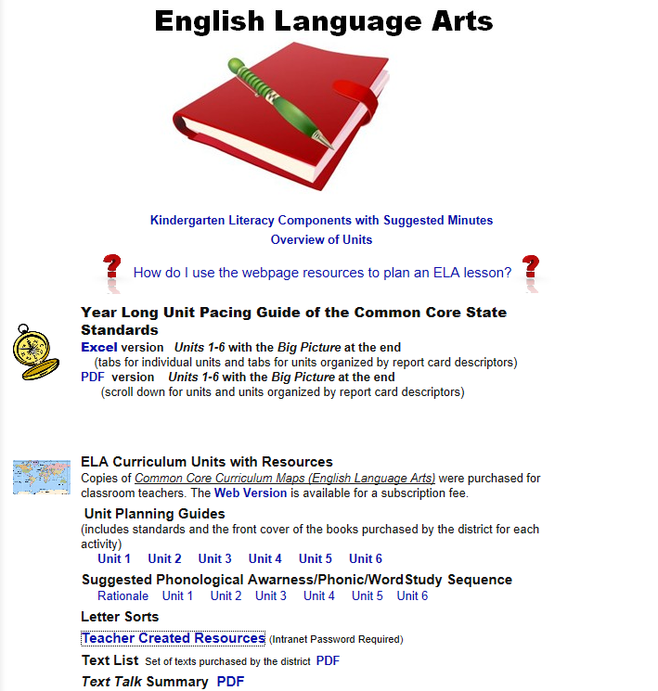
Sites with links to multiple resources
- Variety of Literacy and Math Interactives
- Lengthy list of Interactive Resources for Literacy, Math, and More
- Johnnies Math Page--Lots of Math Resources
- 100’s of Websites Broken Down by Subject: Lang Art, Math, Sci, Soc Stud
- Math Interactives
- More Math Interactives
- Reading, Writing, Language Arts Interactives
- Rhyming Games
- National Geographic Little Kids

Teacher Created Resources on RPS Website
- From the RPS homepage, click the following path: Curriculum, Elementary Curriculum, Curriculum By Grade Level, Kindergarten, Teacher Created Resources , then LOG-IN (at top of page)
(or click here)

Ideas for teaching
http://pinterest.com/marrog/social-studies-ideas/
http://pinterest.com/pediastaff/presidents-day-activities/
https://sites.google.com/site/ateachersbagoftricks/pinterest-boards

